**Project Design Phase-II**

**Technology Stack (Architecture & Stack)**

|  |  |
| --- | --- |
| Date | 03 October 2023 |
| Team ID | NM2023TMID08200 |
| Project Name | iRevolution: A Data-driven Exploration of Apple's iPhone Impact in India |
| Maximum Marks | 4 Marks |

**Technical Architecture:**

technical architecture for Tableau involves several crucial components and considerations. First and foremost, it's essential to have well-organized and optimized data sources, which can range from databases to cloud platforms and spreadsheets. For larger-scale or complex environments, a data warehouse like Amazon Redshift or Google BigQuery can be employed to enhance query performance. Implementing Extract, Transform, Load (ETL) processes is pivotal for cleaning, transforming, and aggregating data before it's used in Tableau. Tools like Tableau Prep or other ETL solutions can be invaluable for this purpose. Tableau Server or Tableau Online serves as the hosting platform, with Server being on-premises and Online in the cloud

Guidelines:

1. Include all the processes (As an application logic / Technology Block)
2. Provide infrastructural demarcation (Local / Cloud)
3. Indicate external interfaces (third party API’s etc.)
4. Indicate Data Storage components / services
5. Indicate interface to machine learning models (if applicable)

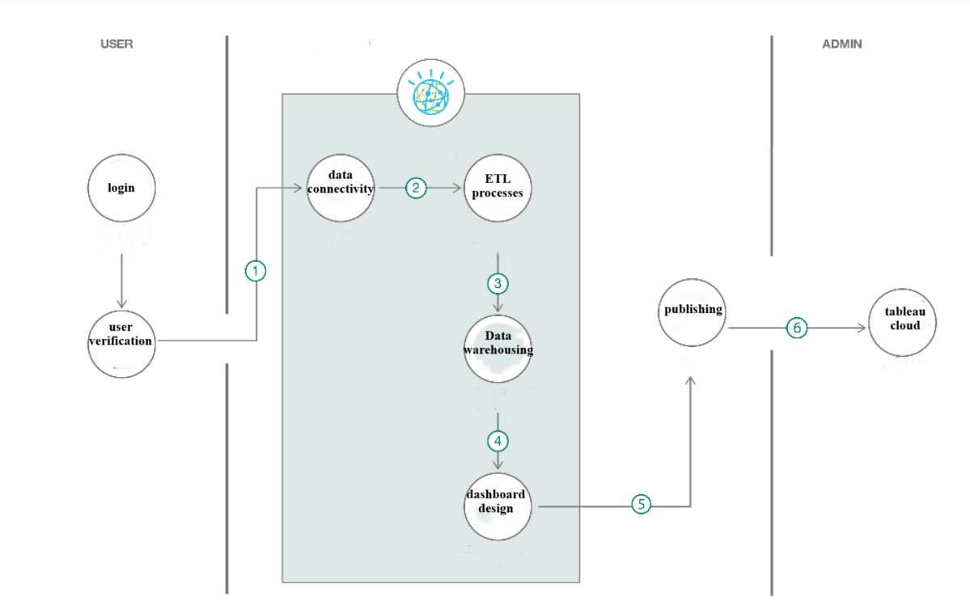

**Table-1 : Components & Technologies:**

|  |  |  |  |
| --- | --- | --- | --- |
| **S.No** | **Component** | **Description** | **Technology** |
| 1. | User Interface | How user interacts with application e.g. Web UI, Mobile App | HTML, CSS |
| 2. | Application Logic-1 | Logic for a process in the application | Java / Python |
| 3. | Application Logic-2 | Logic for a process in the application | tableau desktop |
| 4. | Application Logic-3 | Logic for a process in the application | Tableau workbook |
| 5. | Database | Data Type, Configurations etc. | MySQL |
| 6. | Cloud Database | Database Service on Cloud | Tableau cloud. |
| 7. | File Storage | File storage requirements | Local file |
| 8. | External API-1 | Purpose of External API used in the application | Tableau applications. |
| 9. | External API-2 | Purpose of External API used in the application | Apple phones data |
| 11. | Infrastructure (Server / Cloud) | Application Deployment on Local System / Cloud Local Server Configuration:  Cloud Server Configuration : | Local, Cloud Foundry. |

**Table-2: Application Characteristics:**

|  |  |  |  |
| --- | --- | --- | --- |
| **S.No** | **Characteristics** | **Description** | **Technology** |
| 1. | Open-Source Frameworks | List the open-source frameworks used | Technology of Opensource framework |
| 2. | Security Implementations | List all the security / access controls implemented, use of firewalls etc. | e.g. SHA-256, Encryptions, IAM Controls, OWASP etc. |
| 3. | Scalable Architecture | Justify the scalability of architecture (3 – tier,  Microservices) | Technology used |
| **S.No** | **Characteristics** | **Description** | **Technology** |
| 4. | Availability | Justify the availability of application (e.g. use of load balancers, distributed servers etc.) | Technology used |
| 5. | Performance | Design consideration for the performance of the application (number of requests per sec, use of Cache, use of CDN’s) etc. | Technology used |

**References**

<https://public.tableau.com>

<https://www.tableau.com/products/cloud-bi>